Mockito Hands-On Exercises

Exercise 1: Mocking and Stubbing:

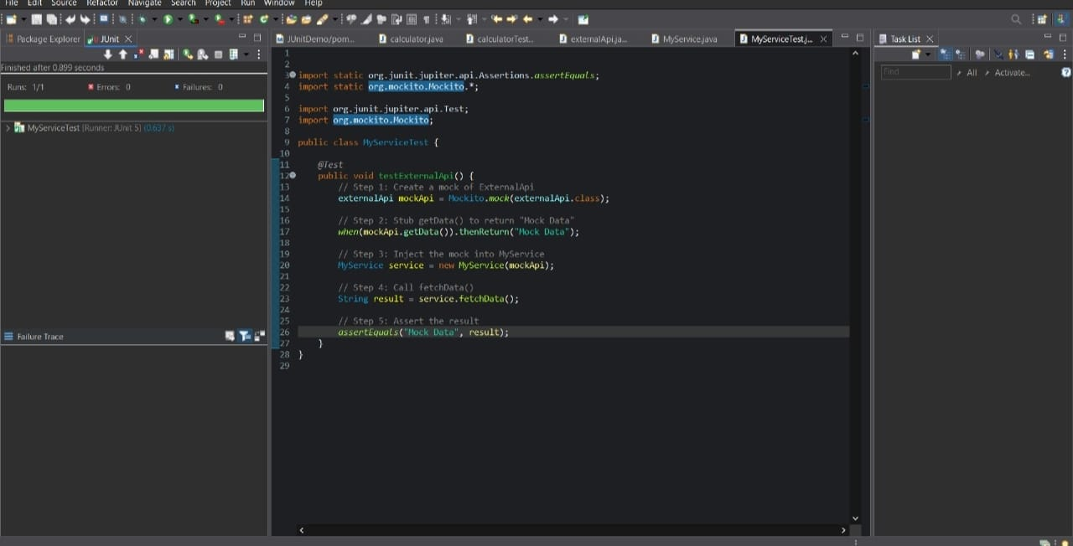

Exercise 2: Verifying Interactions: